PRODUCTION

Output
- Remove “Actual Scrap Qty.”
- Remove the “Scan to Bin” page.
- Enter Quantity
  - Finished Good: Fix the quantity value. It should default to the alternate UOM with PAL.
  - Intermediate: Default the output quantity to zero for intermediate items. These items will not have an alternate UOM of PAL.
- Production Line: Per previous request, display a page for the production line.
- Lot Number: The format is wrong. Once the production line is grabbed, use the clock to define the work shift (S1, S2, S3).
- Expiration Date: This page is not needed. Business Central will assign it based on the posting date plus the item’s expiration calculation.
- License Plate: Only display the LP page for Finished Good items. Note that the system should automatically create the LP in the background. The label should automatically be printed.

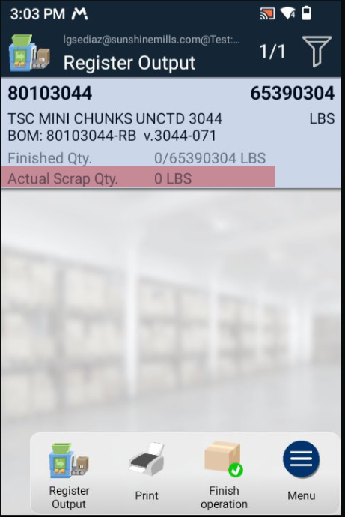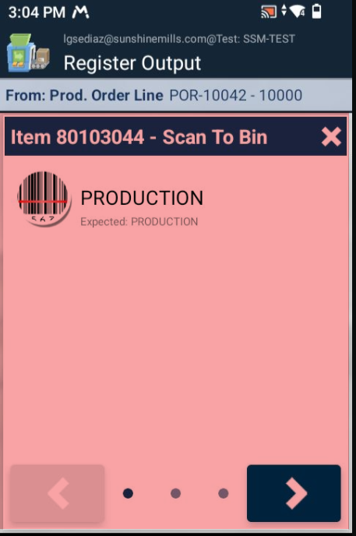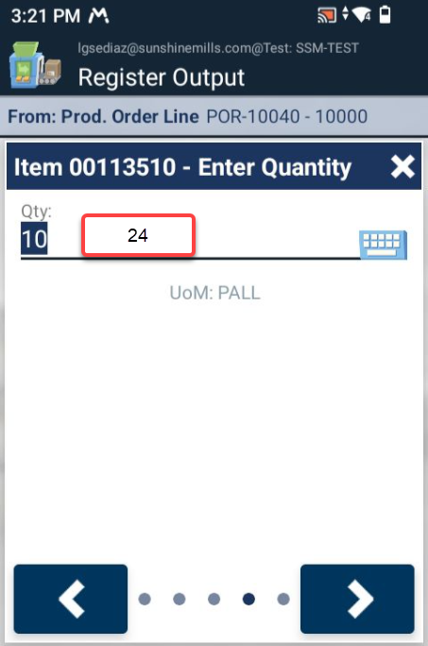
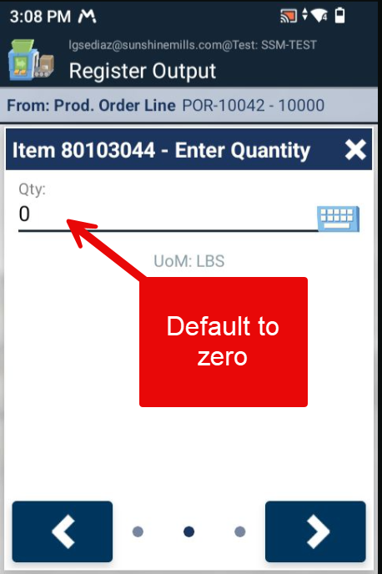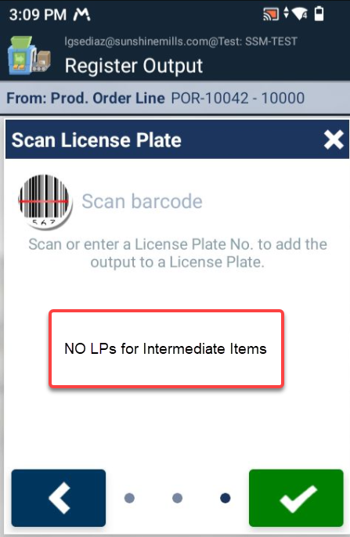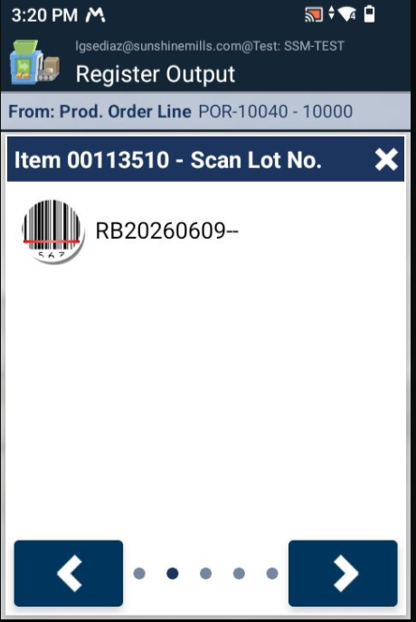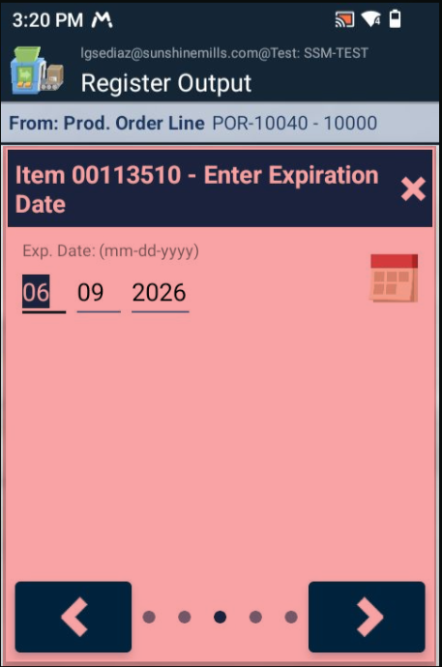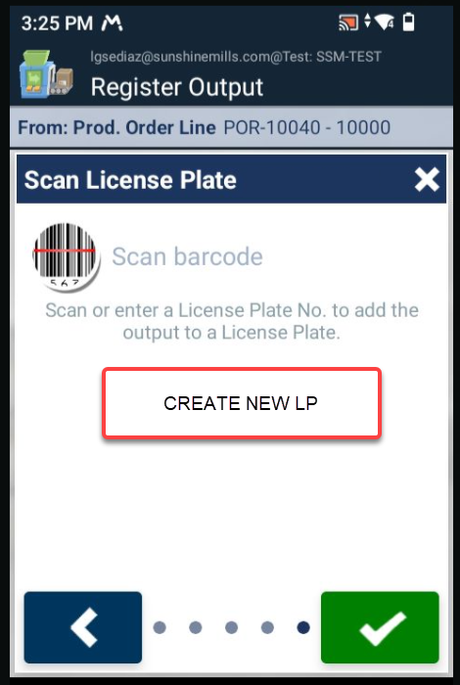

Consumption
- The consumption quantity should display the expected quantity.
- Round the Quantity Per value to five decimals.
- Scanned an LP and got an error. Some raw materials will be received and moved using license plates. There needs to be a way to consume from an LP.

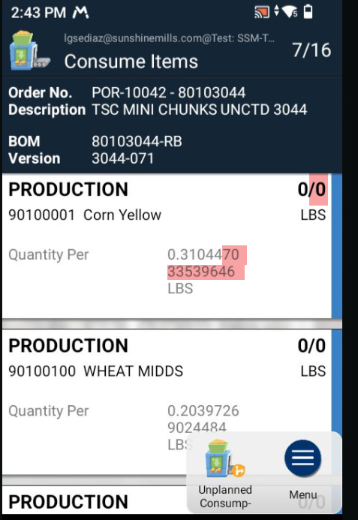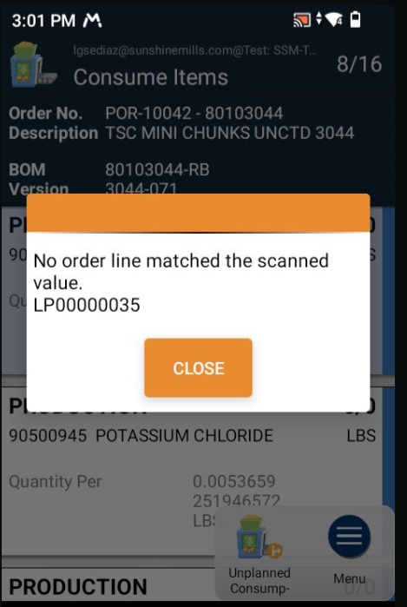

Business Central > License Plate List
- There needs to be a way to identify license plates by their content. For instance, how many license plates contain item 06600125 (Salt)?
- Add the Description field to the license plate line.
